Course Name: Programming in java

Code: PRJ190901

Sem: III

Program: Information Technology

Mini Project Title: Mehndi Management System

Name: Iqra Khatib

SAP ID: 57298210048

ROLL NO: T048

Brief Description about Mini Project:

A text based Java program to implement some of the most basic features of mehndi management system. It implies about the various types of designs along with the price.

Features:

User can view Menu of designs with its price.

Bill of designs is also generated .

Software used: JDK16

Logo:



Description: The Java Development Kit (JDK) is a software development environment used for developing Java applications and applets.

It includes the Java Runtime Environment (JRE), an interpreter/loader (java), a compiler (javac), an archiver (jar), a documentation generator (javadoc) and other tools needed in Java development.

As a major programming language throughout the past few decades, Java has been integral to computer science, and the Java JDK is the essential vehicle for establishing a development environment.

People new to Java may be confused about whether to use the JRE or the JDK. To run Java applications and applets, simply download the JRE. However, to develop Java applications and applets as well as run them, the JDK is needed

**Source code**:

**package** com.mehndi;

**import** java.util.Scanner;

**class** Mehendi {

**int** feed_rate;

**char** con;

String name,feedback,y;

**int** n,i,choice,p;

**int** price[]=**new** **int**[10];

**int** digit[][]= **new** **int**[30][30];

**int** quantity[]=**new** **int**[30];

Scanner sc=**new** Scanner(System.***in***);

**void** title()

{

**int** choice;

System.***out***.println("\t\t\t\t Welcome to Mehndi Store \t\t\t\t");

System.***out***.println(" \t\t\t * * * * Menu of Designs * * * * \t\t\t");

System.***out***.println(" \t 1.Simple Rs.100 \t ");

System.***out***.println(" \t 2.Arabic Rs.300 \t ");

System.***out***.println(" \t 3.Turkey Rs.350 \t ");

System.***out***.println(" \t 4.Dubai Rs.450 \t ");

System.***out***.println(" \t 5.One Hand Rs.200 \t ");

System.***out***.println(" \t 6.Two Hand Rs.500 \t ");

System.***out***.println(" \n ");

System.***out***.println("Enter how many designs you want to apply? ");

n=sc.nextInt();

**for**(i=1;i<=n;i++)

{

System.***out***.println("Enter the Mehendi Design you want to Select ");

digit[i][i]=sc.nextInt();

quantity[i]=sc.nextInt();

}

System.***out***.println(" \n");

System.***out***.println(" \t\t\t\t BILL \t\t\t\t");

System.***out***.println(" \n");

System.***out***.println(" \t\t\t Mehendi Name \t\t\t Quantity \t\t\t Total Price");

**for**(i=1;i<=n;i++)

{

**switch**(digit[i][i])

{

**case** 1:

{

price[i]=100*quantity[i];

System.***out***.println("\t\t\t Simple"+"\t\t\t\t"+ quantity[i]+"\t\t\t\t"+price[i]);

**break**;

}

**case** 2:

{

price[i]=300*quantity[i];

System.***out***.println("\t\t\t Arabic"+"\t\t\t\t"+ quantity[i]+"\t\t\t\t"+price[i]);

**break**;

}

**case** 3:

{

price[i]=350*quantity[i];

System.***out***.println("\t\t\t Turkey"+"\t\t\t\t"+ quantity[i]+"\t\t\t\t"+price[i]);

**break**;

}

**case** 4:

{

price[i]=450*quantity[i];

System.***out***.println("\t\t\t Dubai "+"\t\t\t\t"+ quantity[i]+"\t\t\t\t"+price[i]);

**break**;

}

**case** 5:

{

price[i]=200*quantity[i];

System.***out***.println("\t\t\t One Hand "+"\t\t\t\t"+ quantity[i]+"\t\t\t\t"+price[i]);

**break**;

}

**case** 6:

{

price[i]=500*quantity[i];

System.***out***.println("\t\t\t Two Hand "+"\t\t\t\t"+ quantity[i]+"\t\t\t\t"+price[i]);

**break**;

}

**default**:

{

System.***out***.println("\t\t\t Wrong Choice !!! \t\t\t");

**break**;

}

}

}

System.***out***.println(" \t CONTINUE? (Y/N)");

**char** con=sc.next().charAt(0);

**if**(con=='Y' || con=='y')

{

title();

}

**else**

{

System.***out***.println(" \n");

System.***out***.println(" \t\t\t THANK YOU FOR VISITING - VISIT AGAIN \t\t\t ");

}

}

}

class information1{

String fname,lname,address;

Scanner sc = new Scanner(System.in);

void get1(){

System.out.println("Enter First Name : ");

fname=sc.nextLine();

System.out.println("Enter Last Name : ");

lname=sc.nextLine();

System.out.println("Enter Address Name : ");

address=sc.nextLine();

}

void set1(){

System.out.println(" First Name : "+fname);

System.out.println(" Last Name : "+lname);

System.out.println(" Address : "+address);

}

}

class information2 extends information1{

int age,dob;

Scanner sc = new Scanner(System.in);

void get2(){

System.out.println("Enter Age : ");

age=sc.nextInt();

System.out.println("Enter Date of Birth : ");

dob=sc.nextInt();

}

void set2(){

System.out.println(" Age : "+age);

System.out.println(" Dob : "+dob);

}

}

**package** com.mehndi;

**public class** MehndiMain extends Mehndi{

**public** **static** **void** main (String args[])

{

Scanner sc = new Scanner(System.in);

information2 i2= new information2();

i2.get1();

i2.get2();

i2.set1();

i2.set2();

Mehendi obj1 = **new** Mehendi();

obj1.title();

}

}

**Output**:

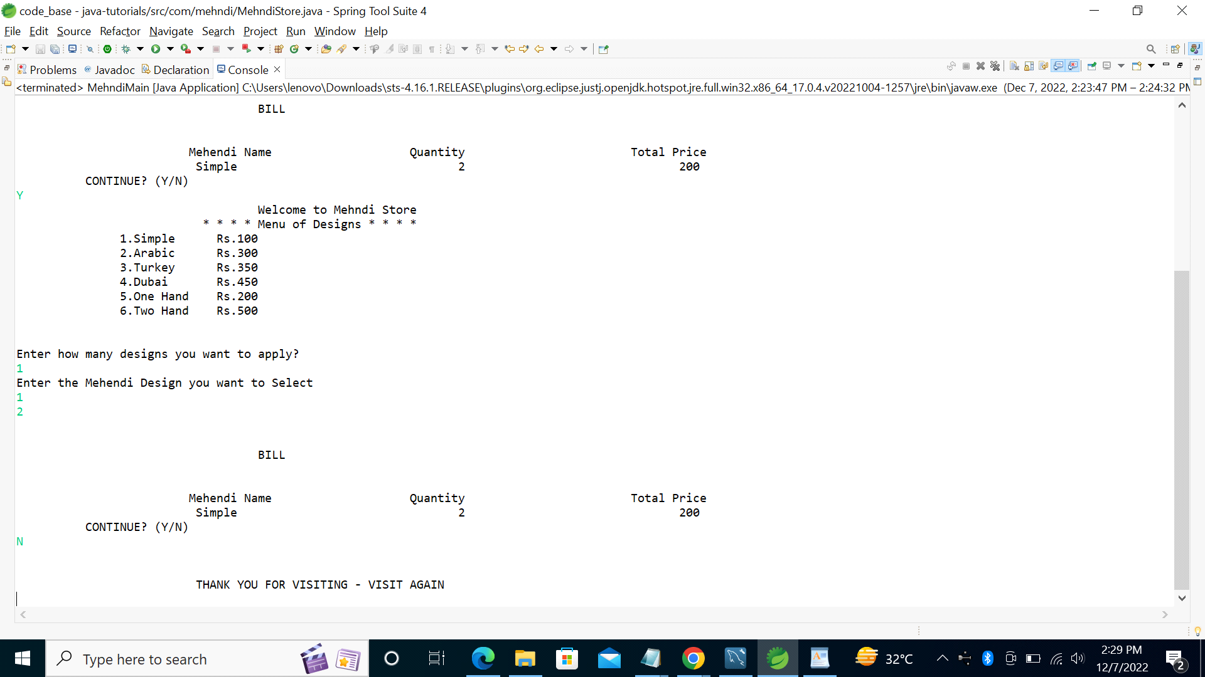

**Future Scope**: In future I will add some features like:

1. I will use Graphical user interface (GUI) to make it more attractive .

2. I will also add Database connectivity to store data from user.

3. Addition for previous details of a consumer will be added.

4. This would be enhanced as a web based project adding appointments for the customers along with their details.

CONCLUSION: By developing this mini project I got to know about real life program system in java by making this project. I also explored some new features of java by mini project .

~~~*************~~~